Introduction

The system EasyDiet facilitates the planning, preperation and administration of diets, which helps dietitians to create dietplans. EasyDiet offers the functionality to create dietplans and manage the patients.
The manual describes the installation and how to operate with the program.

Product information

Scope
EasyDiet offers the following features:
- searching and choicing of patients
- supported creation of diet plan

Systemvoraussetzungen
Your computer system needs following requirements to run EasyDiet without problems:
- Pentium computer, at least 266 MHz
- Java Virtual Machine (JVM) must be installed
- Operating system:
  - Windows XP, SP2 (32 or 64 Bit) or
  - Windows Vista (32 or 64 Bit) or
  - Windows 7 (32 or 64 Bit)
- At least 500 MB of free space on hard drive
- At least 1 GB of RAM

Installation

Datenbase
Fill your database with the included file fhv_easy.sql.gz
Open the file database.proberties and specify your database configurations and save.
You can start the program now by running the run.bat file.

EasyDiet im Überblick
This chapter gives you an overview of the functionality and operation of EasyDiet
- chapter: navigation
- chapter: how to be done

Navigation

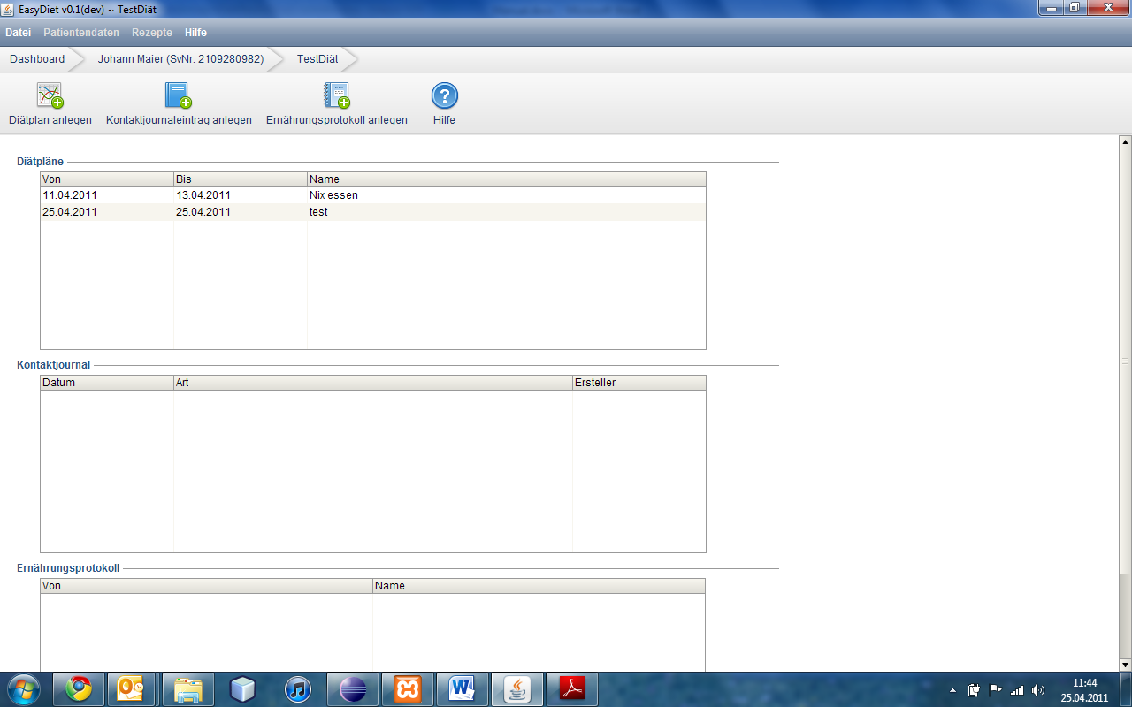
There are 3 menu items for the basic navigation through the program
- menu bar (yellow)
- hierarchy bar (red)
- menu buttons (green)
In the menu bar you can select basic commands which are available for the whole programm. In contrast, the menu buttons depend on the respective mask. You can add new elements adicted of the respective mask.
The hierarchy bar gives you an overview where in the programm you are. To go back in a higher hierarchy, click on the right button in the hierarchy bar.

So wird es gemacht

Patient auswählen
Starting point: Dashboard
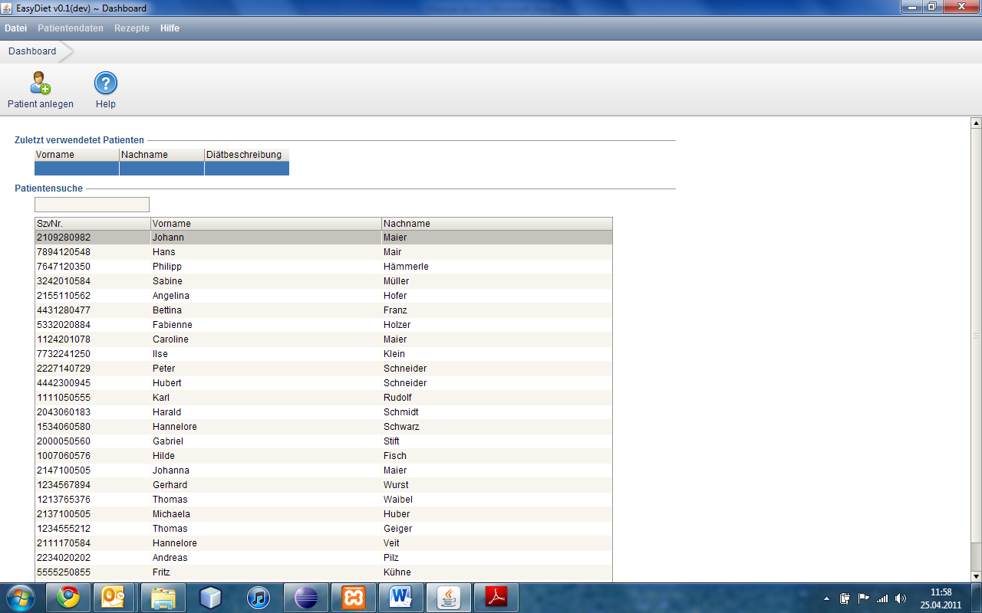

For searching a patient, please type the firstname, lastname or social security number into the searchbox(marked in red). If you get a right result, please doubleclick the line of the desired patient. So you get into the diet treatment overview. If the search is not successful, please check the entered cretaria or contact the administrator.
In addition, the table can be sorted by clicking on one of the three column headings in ascending/descending order.

Diätbehandlung auswählen
Startingpoint: Diet Treatment View
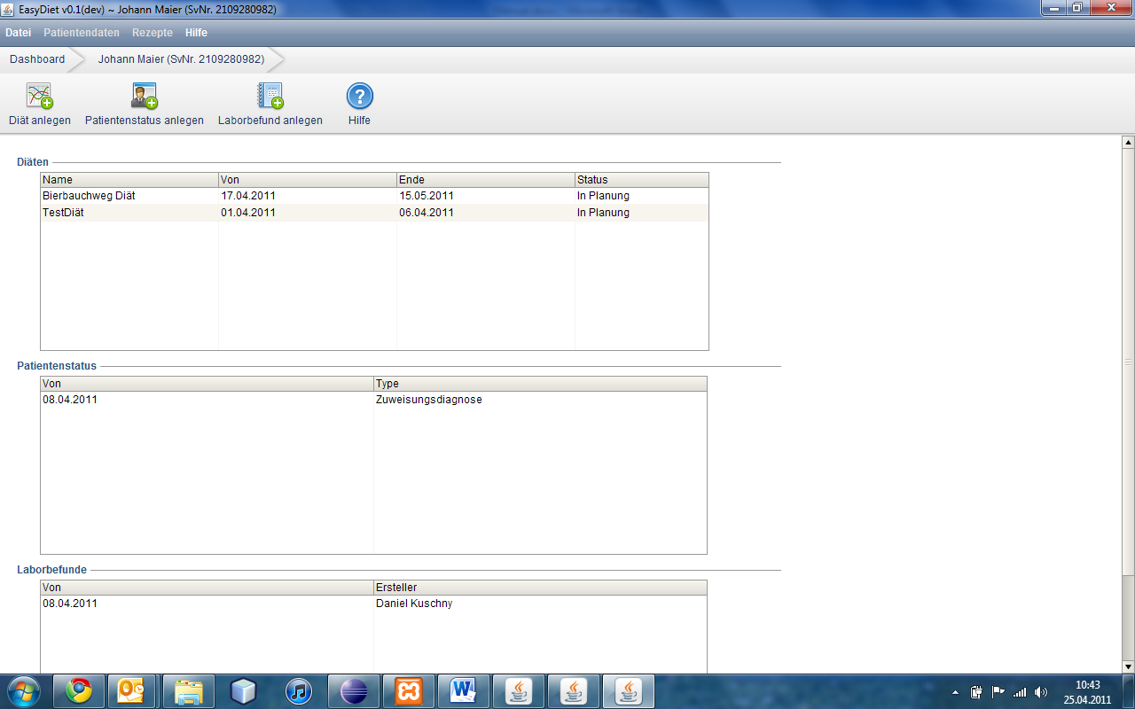
In the diet treatment view you can see all diet treatments of the desired patient. To open the diet treatment, please doubleclick the desired diet treatment

Diätplan anlegen
Startingpoint: diet plan view
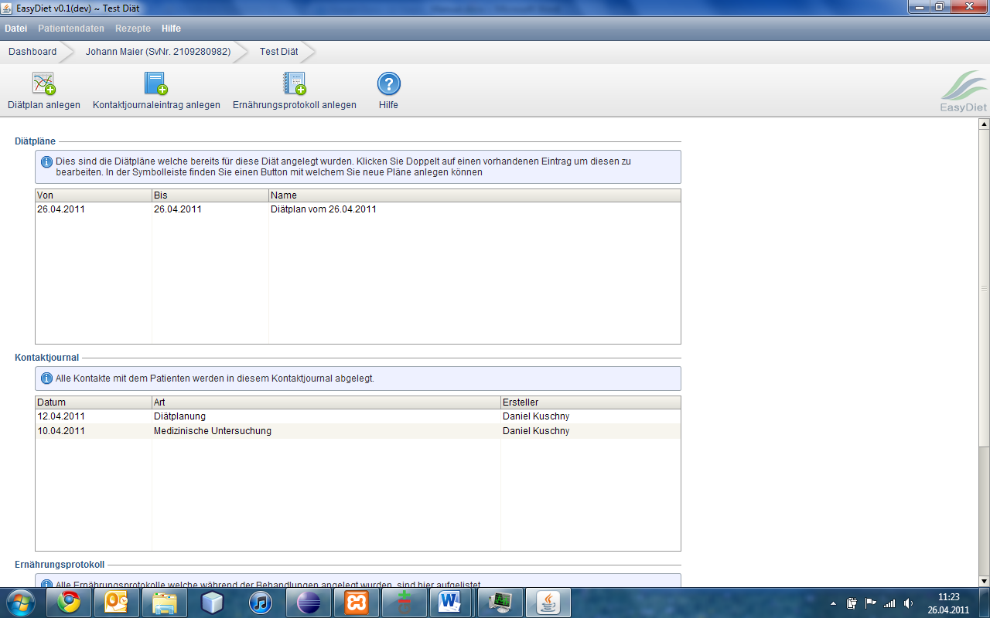
If you click on the „Create Dietplan“ button, you get into the diet plan view. First you have the possibility to add some diet parameters for the diet plan. For that, please click on „Add Parameter“. You can change a field by doubleclicking it. Now you can select a parameter and enter the appropriate values to be observed including their unit.
If you want to delete a parameter, click on a parameter in the table and click on the „Delete Parameter“ button.
Meanings of operators:
Operator | explanation | example | Example explanation
> | Parameterdefinition „larger“ than value | Alanin > 100 mg/100g | Parametervalue has to be larger than 100
< | Parameterdefinition „smaler“ than value | Alanin < 100 mg/100g | Parametervalue has to be smaler than 100
>= | Parameterdefinition „greater than or equal to“ value | Alanin >= 100 mg/100g | Parametervalue greater 100 or equal 100
<= | Parameterdefinition „smaler than or equal to“ value | Alanin <= 100 mg/100g | Parametervalue smaler 100 or equal 100
= | Parameterdefinition „equal“ to value | Alanin = 100 mg/100g | Parametervalue has to be exakt 100
!= | Parameterdefinition „not equal“ to value | Alanin < 100 mg/100g | Parametervalue must not be 100

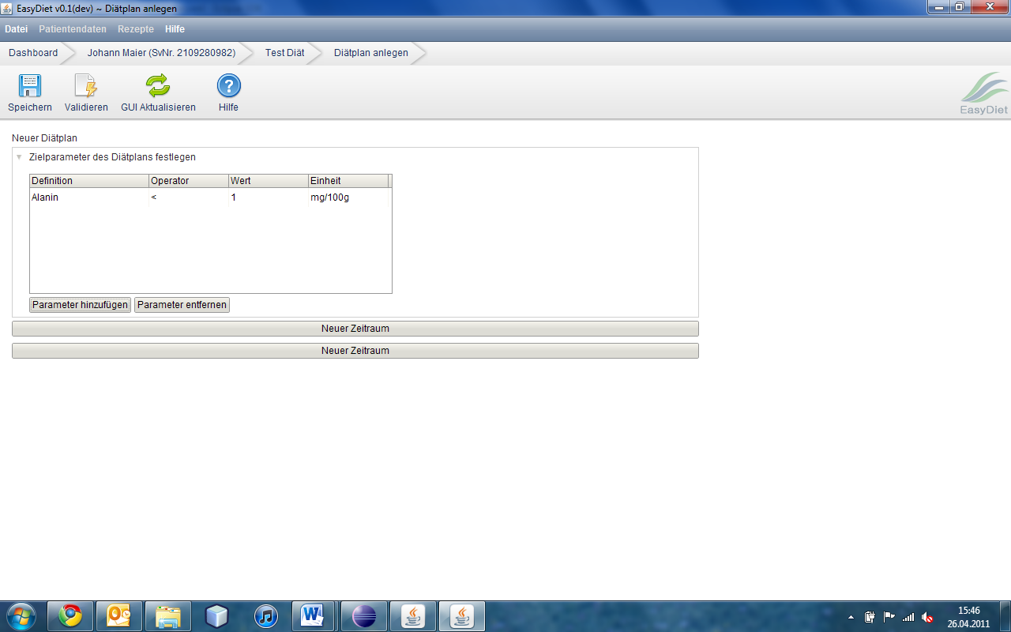
To start creating the diet plan, define a startdate and a timespan first. Therefore click on the „New Timespan“ button. Now you can put in a startdate and a timespan. If you want, you can put some diet parameters to the timespan.

For adding a new meal for the timespan, click on the „New Meal“ button.
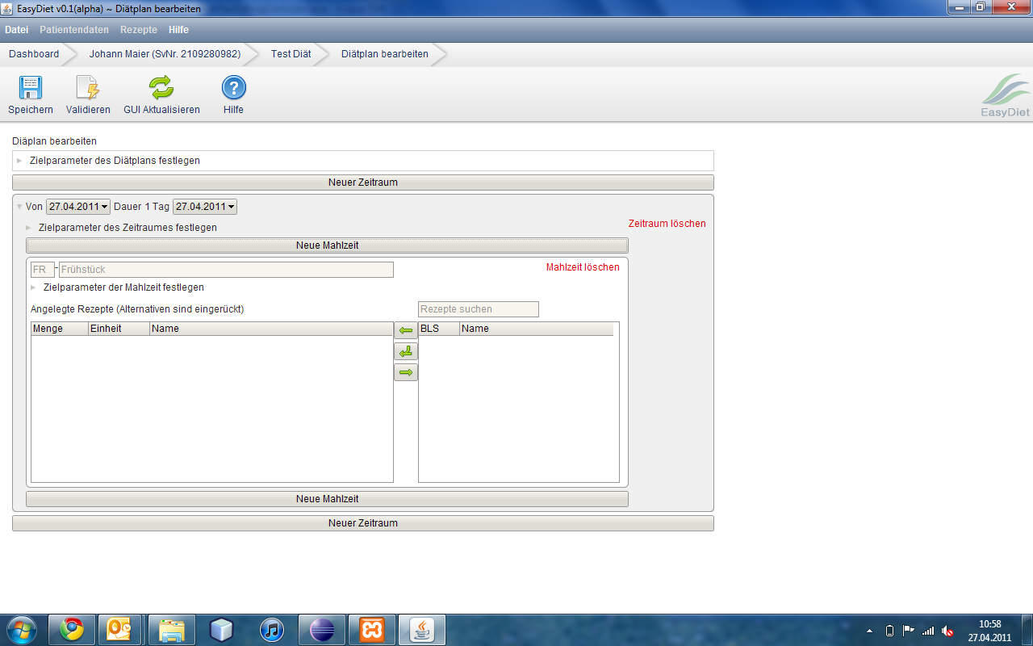
Now you can write a name and a code to the meal. You also can add some diet parameters to the meal.
Then you can add recipes to the meal. Type the desired recipe into the search box (marked in green). The system shows you immediatly availible recipes. To add a recipe to the meal, please mark the recipe and click on the „add“ button (marked in red). If you want to add an alternative recipe, search this recipe as the recipe before. Mark it again an click on the „add alternative recipe“ button (marked in blue).
If you want do delete a recipe, mark it on the meal table and click the „delete“ button (marked in yellow).

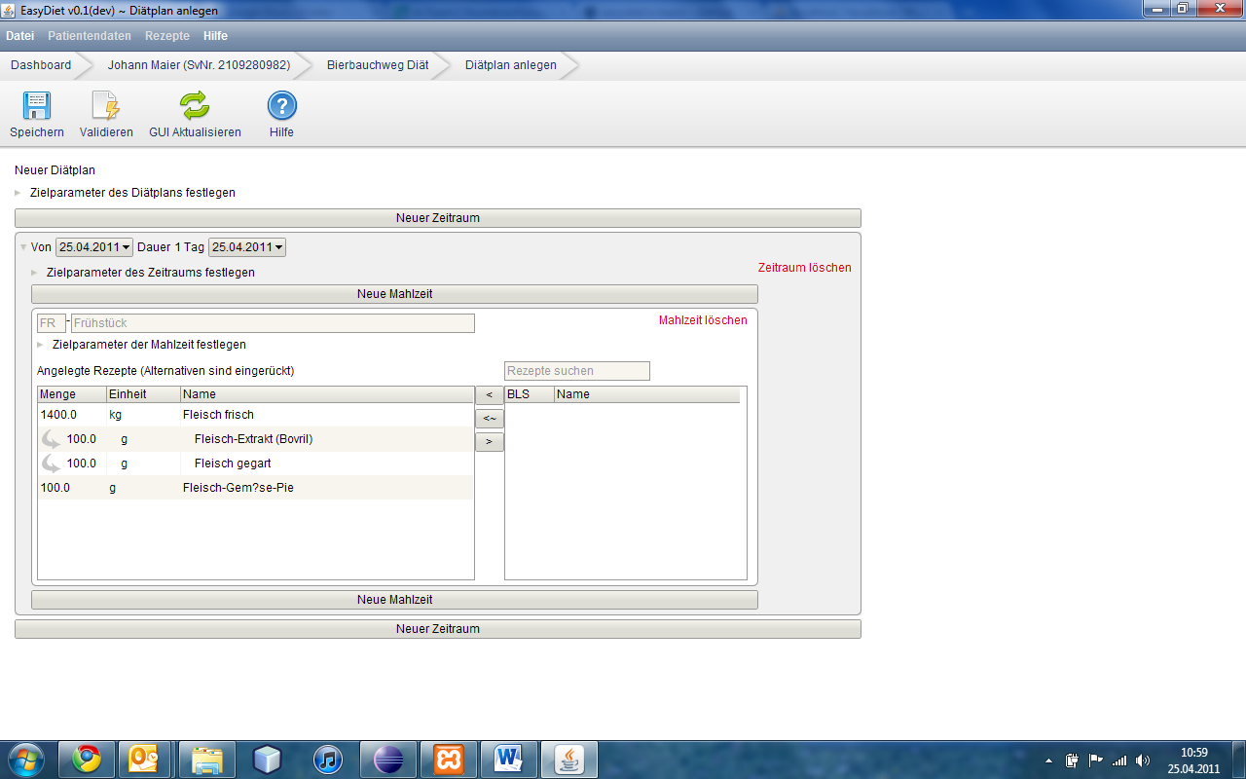
You can aware alternative recipes because they are engaged.
TIP: To add multiple alternatives recipes, select several recipes and choose the recipe on the left side, which should get an alternative recipe and click the „add alternative recipe“ button (marked in blue). Repeat this process for every meal, every timespan and every diet plan. Finally, you have to click the "Validate" button to indicate the errors in the diet plan. If there are any errors, you have to resolve them bevore saving the diet plan. If not, click the „Save“ button and the diet plan is stored in the database.

